**Azure Speech to Text Security Patterns**

Date: 27 November 2019

Version: 1.0

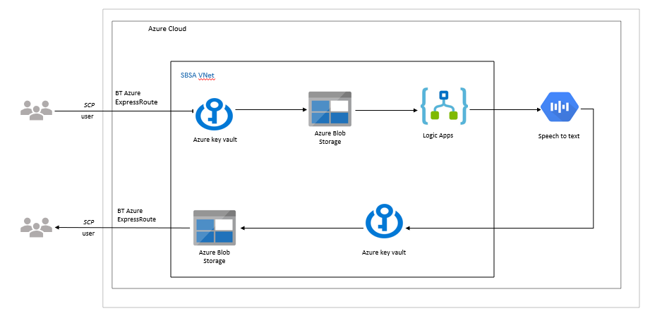

**Methods of encrypting objects in Azure Storage**

1. Storage Service Encryption (SSE): Automatically encrypts all data in Azure Storage using 256-bit AES encryption.
2. Azure Key Vault: User must be authenticated by Azure AD

* Authentication establishes the identity of the caller
* Authorization determines which operations the caller can perform

1. Client-Side Encryption
2. Disk Encryption

In the Cognitive Services team, we will focus mainly on SSE and Azure Key Vault

**Data encryption from on-premises to Azure Storage**

All our data in Storage will have a storage policy to enforce encryption on upload.

**Data encryption in Azure Storage**

* All our data in Azure Storage will be encrypted with Azure Key Vault
* Access to our Key Vault will be restricted via a Key Vault access policy to users consuming the service
* You can also monitor how and when your key vaults are accessed and by whom. See in detail the Azure Key Vault documentation: <https://docs.microsoft.com/en-us/azure/key-vault/>

**Data encryption from Azure Storage to Azure Speech to Text**

**Encryption at Rest**

Azure Speech to Text uses the default SSE for encryption of transcripts placed in Azure Blobs. When you start transcription job, you can specify your own Key Vault key to encrypt the output from a transcription job.

Azure Speech services keys can be stored securely using Azure Key Vault.

**Encryption in Transit**

Azure Speech to text uses Transport Layer Security (TLS) protocol to encrypt data in transit. This includes streaming transcriptions.

**Key Management**

Azure Speech Services works with Azure Key Vault to provide enhanced encryption for your data. Azure Blobs enables you to encrypt your input audio when creating a transcription job. Integration with Key vault enables you to encrypt the output of the transcription job.

If you don’t specify an encryption key the output of the transcription job is encrypted with the default Azure SSE.